FOR OFFICERS IN BPS 19 & 20 CONFIDENTIAL



GOVERNMENT OF KHYBER PAKHTUNKHWA

Ministry /Division/ EXCISE TAXATION & NARCOTICS CONTROL DEPARTMENT
Service/Group

Department/Office


PERFORMANCE EVALUATION REPORT


FOR THE PERIOD TO

PART I

(TO BE FILLED IN BY THE OFFICER REPORTED UPON)


- Name (in block letters

- Personnel number

- Date of birth

4. Date of entry in service

5. Post held during the period (with BPS)

- Academic qualifications

- Knowledge of languages (Please indicate proficiency in speaking (S), reading (R) and writing (W)


8. Training received during the evaluation period (Training courses attended earlier,
if any, may please be listed separately on the back page of the report).


Name of course attended   | Duration with dates   | Name of institution and country  
9. Period served

(i) In present post (ii) Under the reporting officer
 | 
PART II
(TO BE FILLED IN BY THE OFFICER REPORTED UPON)

1. Job description


2. Brief account of achievements during the period supported by statistical data where possible. Targets given and actual performance against such targets should be highlighted. Reasons for shortfall, if any, may also be stated.

PART III

(EVALUATION BY THE REPORTING OFFICER)


- Please comment on the officer's performance on the job as given in Part II (2) with special reference to his knowledge of work, ability to plan, organize and supervise, analytical skills, competence to take decisions and quality and quantity of output. How far was the officer able to achieve the targets? Comment on the officer's contribution, with the help of statistical data, if any, in the overall performance of the organization. Do you agree with what has been stated in Part II (2)?
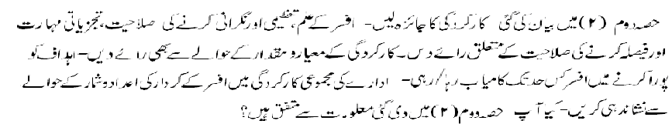

2. Integrity (Morality, uprightness and honesty)


3. Pen picture including the officer's strengths and weaknesses with focus on emotional stability, ability to work under pressure, communication skills and interpersonal effectiveness. (Weakness will not be considered as adverse entry unless intended to be treated as adverse). 

4. Area and level of professional expertise with suggestions for future posting.


5. Training and development needs.


6. Overall grading


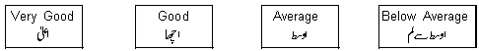

7. Fitness for promotion Comment on the officer's potential for holding a higher
 position and additional responsibilities.

Name of the reporting officer Signature
(Capital letters)


Designation Date

PART IV

(REMARKS OF THE COUNTERSIGNING OFFICER)


1. How often have you seen the work of the officer reported upon?


Very frequently   | Frequently   | Rarely   | Never  

2. How well do you know the officer? If you disagree with the assessment of
the reporting officer, please give reasons.

3. Overall grading

4. Recommendation for promotion (Comment on the officer's potential for holding a
 higher position and additional responsibilities).

5. Evaluation of the quality of assessment made by the reporting officer.

Exaggerated   |  | Fair   |  | Biased  

Name of the countersigning officer Signature
(Capital letters)


Designation Date

PART V

REMARKS OF THE SECOND COUNTERSIGNING OFFICER (IF ANY)


Name Signature


Designation Date

